 | Appendix 8
 | Mandatory Disclosure for MCA Programme
1. | AICTE File No. | North-West/1-2814383379/2017/EOA
 | Date & Period of last approval | 05.04.2016

2. | Name of Institution | Gian Jyoti Institute of Management & Technology
 | Address of Institution | Phase-2
 |  | Mohali.
 | City & Pin Code | Mohali -160 055
 | State/UT | Mohali, Punjab
 | Longitude & Latitude | 76.69, 30.78
 | Phone number with STD code | 0172-2264566
 | FAX number with STD code | 0172-2266979
 | Office hours at the Institution | 9.00 am to 5.00 pm
 | Academic hours at the Institution | 9.00 am to 4.00 pm
 | Email | gjimt@gjimt.com
 | Website | www.gjimt.ac.in
 | Nearest Railway Station (dist in KM) | At Mohali (8 km)
 | Nearest Airport(dist in KM) | At Mohali (13km)

3. | Type of Institution | Private –Self Financed
 | Category(i) of the Institution | Non Minority
 | Category (2) of the Institution | Co-Ed

4. | Name of the organization running the Institution | Gian Jyoti Educational Society
 | Type of the organization | Society
 | Address of the organization | Gian Jyoti Educational Society
 |  | Phase-2, Mohali
 | Registered With | Registrar of Societies ,Punjab
 | Registration Date | 10.12.1976
 | Website of the organization | www.gjimt.ac.in

5. | Name of the affiliating University | I.K.G
 | Address | Jalandhar-Kapurthala Road, Jalandhar
 | Website | www.ptu.ac.in
 | Latest affiliation period | 2016-17

6. | Name of Principal/Director | Dr. Aneet
 | Exact Designation | Director
 | Phone number with STD code | 0172-2264566
 | FAX number with STD code | 0172-2266979
 | Email | aneet@gjimt.ac.in
 | Highest Degree | Ph.D
 | Field of Specialization | HR.

7. |  | Governing Board Members
 | Name |  | Academic Qualification |  | Nature of Association with the Promoting Body |  | Experience in Academic Institutions  (in Years) |  |  | Overall Experience  (in Years)
 |  |  | Technical | Non Technical |  |  | Promotional | Management | Organizational
 | Sh. A.D.Nagpal |  | - | B.A | Chairman |  | - | - | - | 48 yrs
 | Sh. Jaswant Singh Bedi |  | L.L.B. | B.A., | Secretary |  | - | 45 yrs | - | 45 yrs
 | Smt. Ranjeet Kaur Bedi |  | B.Ed | M.A., | Treasurer |  | - | - | 42 yrs | 42 yrs
 | Dr.S.P.S.Chawla |  | MBBS (MRSIA) | - | Member |  | - | - | - | 36 yrs
 | Sh. Harjit Singh |  | MBA |  | Member |  | - | - | - | 42 yrs
 | Dr. R.P. Gupta |  | Ph.D | M.Sc. | Member |  | - | - | 40 yrs | 40 yrs
 | Sh. Vivek paul |  |  | MA.,BA | Member |  | - | - | - | 20 yrs
 | Mrs. Gian Jyot |  | B. Ed. | MA | Member |  | - | - | 14 yrs | 14 yrs
 | Dr. Aneet |  | PhD,MBA | B.Sc | Member |  | - | 17 yrs | - | 17 yrs
 |  | Frequency of meetings & date of last meeting |  |  |  | Twice a year

8. | Academic Advisory Body |  |  | List of Members given below
 |  | 1 | Sh. A.D.Nagpal |  | Chairman
 |  | 2 | Sh. J.S.Bedi |  | Secretary
 |  | 3 | Mrs. Ranjeet Bedi |  | Treasurer
 |  | 4 | Dr. Prem Kumar |  | Member

 |  | 5 | Sh. J.D, Ghai |  | Member
 |  | 6 | Sh. J. B. Singh |  | Member
 |  | 7 | Sh. Anupam Gakhar |  | Member
 |  | 8 | Sh. Swaranjit Singh |  | Member
 |  | 9 | Dr. S.P.S.Chawla |  | Member
 |  | 10 | Sh.Gurmeet Singh Bhatia |  | Member
 |  | 11 | Dr. Aneet |  | Member
 |  | 12 | Mrs. Gian Jyot |  | Member
 |  | 13 | Mr. Gurvinder Singh |  | Member
 |  | 14 | Mr. Rohit Aggarwal |  | Member
 |  | 15 | Sh. Vivek Paul |  | Member
 | Frequency of meeting & date of last meeting |  |  | Twice a Year

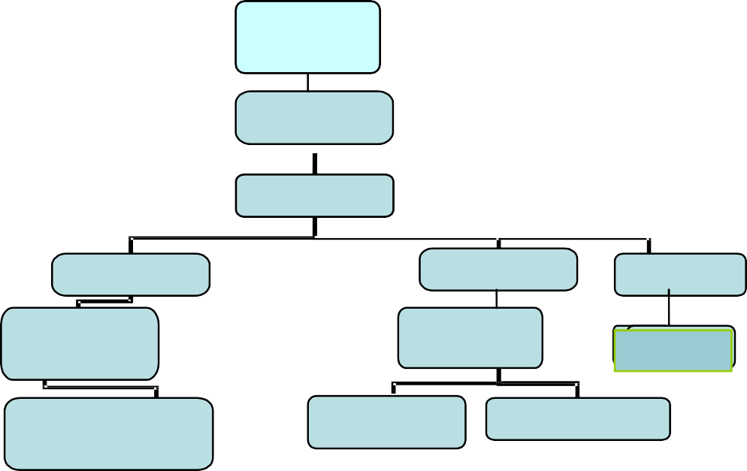
9.
Organizational Chart
Board of
Governors

Chairman
Director
Deans
CAO
Librarian
HOD
Office
suptd.
Astt.lib
Faculty
Security
Officer
Clerk

10. | Student feedback mechanism on Institutional Governance/faculty performance | Standardized format of faculty feedback is taken after semester end

11 | Grievance redressal mechanism for faculty, staff and students | Special Counselling sessions are held daily in the campus

12. |  | Name of Department |  | Information Technology
 |  | Course |  | MCA
 |  | Level |  | PG
 |  | 1st Year of approval by the Council |  | 2002
 |  | Year wise sanctioned Intake |  | 120 120
 |  | Year wise Actual Admission |  | 24 35
 |  | Cut off marks-General quota |  | 55 57
 |  | % Students passed with Di |  | 15 22
 |  | % Students passed with Fi |  | 44 59
 |  | Students Placed |  | 20 25
 |  | Average Pay Package |  | 2.5 Lakhs 2.5 Lakhs
 |  | Students opted for Higher Studies |  | - -
 |  | Accreditation Status of the Course |  | Not Accredited
 |  | Doctoral Courses |  | Yes
 |  | Foreign Collaborations, if any |  | N.A
 |  | Professional Society Memberships |  | List given below.
 | S No |  | Organization |  | Type of Membership
 | 1 |  | The British Library |  | Institutional Member
 | 2 |  | National HRD Network Chandigarh |  | Permanent Institutional Membership
 | 3 |  | Chandigarh Management Association (CMA) |  | Life Membership
 | 4 |  | People Matters HR Magazines |  | Annual Subscription
 | 5 |  | IT Club Chandigarh |  | Life Membership
 | 6 |  | Punjab Commerce & Management Association (PCMA) |  | Life Member
 | 7 |  | The Indus Entrepreneurs (Tie) Chandigarh |  | Annual Tie Membership (Institutional )
 | 8 |  | Indian Society for Training & Development |  | Life Membership
 | 9 |  | Indian Society for Applied Behavioral Science ( ISABS) |  | Life Associate Membership
 | 10 |  | Chandigarh Club |  | Monthly Membership
 | 11 |  | Peta India |  | Annual Membership
 | 12 |  | Computer Society of India |  | Annual Institutional Membership
 | 13 |  | Indian Society for Technical Education |  | Institutional Membership fee
 | 14 |  | ASSOCHAM |  | Annual Member
 | 15 |  | FICCI |  | Annual Member
 | 16 |  | CII |  | Organizational Member
 | 17 |  | IEEE |  | Annual Member
 | 18 |  | DELNET |  | Annual Institutional Member
 | 19 |  | PHDCCI
 |  | Professional Activities |  | AICTE sponsored SDP- FDPs, International & National Conference, HR Summit, Pratibha
 |  | Consultancy activities |  | TBRL, (ADRDO Organisation) Trainning Programme with Groz Beckert Asia Ltd.
 |  | Grants fetched |  | PTU Sponsored –  13th National Conference GJ-NatConMITE -2016  (Grant for Rs. 25,000/-)
 | Departmental Achievements | - Placements in reputed organization like Infosys , Accenture , Smart data , Grey cell Technology Vienna Solutions Net Solutions , OATI .  - Organized various National and International conferences  - PTU Sponsored GianJyoti National Conference on Management, Information Technology, and Engineering, July 23, 2016  - GianJyoti International Conference on Management, Information Technology, and Engineering, March 18, 2017  - PTU Sponsored Five-Days FDP onActivity and Project Based Teaching and Learning from 6thto 10thJuly, 2015  - HR Summit organized for active Industry-Institute Interface: 8th HR Summit on Leadership in Business, October 17, 2015

- Certifications

S. No. | Course Name | Year Introduced | For students of which Semester/Term | Optional or Compulsory | Number of hours per semester/term | Batch Size
1 | Edx.org online certification | 2016 | MBA, MCA, BBA, BCA all semesters | Optional | 14 hrs. per semester | 112
2 | Certification in Digital Marketing | 2016 | MBA, MCA, BBA, BCA all semesters | Optional | 21 hrs. per semester | 112
3 | Certification in HR Essentials | 2016 | MBA Sem. 1 and Sem. 3 | Optional | 21 hrs. per semester | 57
4 | Certification in Supply Chain Management | 2016 | MBA Sem. 1 and Sem. 3 | Optional | 21 hrs. per semester | 25
5 | Certification in Capital Markets | 2016 | MBA Sem. 1 and Sem. 3 | Optional | 21 hrs. per semester | 25
6 | Certification in Business Analytics using Simulation | 2013 | MBA Sem. 1 and Sem. 3 | Optional | 21 hrs. per semester | 25-75
7 | Dining Etiquettes | 2016 | MBA, MCA, BBA, BCA all semesters | Optional | 1 day at Hotel Hyatt | 112
8 | Basic Golf | 2014 | MBA, MCA, BBA, BCA all semesters | Optional | 12 hrs. per semester | 60-112
9 | Functional English | 2013 | MBA, MCA, BBA, BCA all semesters | Optional | 14 hrs. per semester | 100-150
 | Alumni Details
 | SR. | NAME OF THE STUDENT | PRESENT COMPANY NAME |  | DESIGNATION
 | 1 | Roohi Bhatia | Infosys |  | System Engineer
 | 2 | Rajni | Accenture |  | Software Engineer
 | 3 | Ridhu Bala | Grey cell Technology |  | Software Developer
 | 4 | Sandeep Kumar | Bayatree.infocom |  | Software Developer
 | 5 | Gaganpreet Singh | PIford Technologies |  | PHP Trainer
 | 6 | Surbhi | Pacnframes |  | Project Manager
 | 7 | Satinderpal singh | Nvish solutions pvt. Ltd. |  | Software Developer
 | 8 | Purnima Singh | HCL Carrer Techonologies |  | Software Developer
 | 9 | Pradeep Kumar | Intelligia tech. pvt. Ltd. |  | Software Engineer
 | 10 | Monika Saini | TK softech pvt. Ltd |  | Product Specialist
 | 11 | Bhupesh Sharma | OATI |  | Software Developer
 | 12 | Prabhat Kumar | CLI |  | Android Developer
 | 13 | Vivek Gupta | Cogniter Technology |  | Software Engineer
 | 14 | Vaneet Sharma | Smart data |  | Software Engineer
 | 15 | Raghunandan Sharma | Vienna Solutions |  | Software Developer
 | 16 | Priyanka Mittal | Net Solutions |  | Web Designer
 | 17 | Harpreet Kaur | BTES |  | JAVA Trainer
 | 18 | Charu Kheterpal | Safalpek pvt. Ltd |  | Software Developer
 | 19 | Arvind Kumar | Authorgen Tech. |  | Software Engineer
 | 20 | Navjot Kaur | IMPINGE IT Solutions |  | Android Developer

13 | Name of Teaching Staff | Ms. Lata Pant
 | Designation | Asst. Prof.
 | Department | IT
 | Date of Joining the Institution | 27.02.2016
 | Qualifications with Class/Grade | UG: BCA |  |  | PG: MCA
 | Total Experience in Years | Teaching : 2 yrs Research : - |  |  | Industry : 1 yrs
 | Papers Published | National |  | : | International: -
 | Papers Presented in conferences | National |  | - | International | : -
 | PhD Guide?Give field & University | Field : - |  |  | University:-
 | PhDs/Projects Guided | PhDs -  Level:- |  |  | Project at Masters
 | Books Published/IPRs/Patents | -
 | Professional Memberships | -
 | Consultancy Activities | -
 | Awards | -
 | Grants fetched | -
 | Interaction with Professional Institutions | -

13 | Name of Teaching Staff | 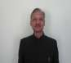  Col.Satish Chander Sood ,Veteran
 | Designation | Professor
 | Department | IT
 | Date of Joining the Institution | 22.07.08
 | Qualifications with Class/Grade | UG ; B.Sc(2nd) ,B.Ed (2nd)  PG: M.Tech Computer Sc.(1st), M.Sc (1st) Ph.D  : -
 | Total Experience in Years | Teaching : 14 yrs Industry : 28 yrs  Research : -
 | Papers Published | National : - International
 | Papers Presented in conferences | National - International : -
 | PhD Guide?Give field & University | Field : - University:-
 | PhDs/Projects Guided | PhDs - Project at Masters Level:-100  Engineering
 | Books Published/IPRs/Patents | Technical and Users Mannals to software developed for Army
 | Professional Memberships | -
 | Consultancy Activities | -
 | Awards | Army Commanders Commendation Card Jan2006
 | Grants fetched | -
 | Interaction with Professional Institutions | -

13 | Name of Teaching Staff | Mr.Sanjay.K.Aggarwal
 | Designation | Asstt.Professor
 | Department | IT
 | Date of Joining the Institution | 15-11-2006
 | Qualifications with Class/Grade | UG ; B.Sc. PG: MBA, M.Tech, Phd(Pursing)  PhD : -
 | Total Experience in Years | Teaching : 15 Yrs Industry : 2yrs  Research : -
 | Papers Published | National : - International
 | Papers Presented in conferences | National :-2 International :- 1
 | PhD Guide?Give field & University | Field : - University:-
 | PhDs/Projects Guided | PhDs - Project at Masters Level:-
 | Books Published/IPRs/Patents | -
 | Professional Memberships | -
 | Consultancy Activities | -
 | Awards | -
 | Grants fetched | -
 | Interaction with Professional Institutions

13 | Name of Teaching Staff | 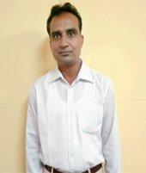  Mr.Chamkaur Singh
 | Designation | Asst.Prof.
 | Department | IT
 | Date of Joining the Institution | 21.08.07
 | Qualifications with Class/Grade | UG ; B.Sc (2nd)  PhD : - | PG: MCA(1st)
 | Total Experience in Years | Teaching : 13 yrs Research : - | Industry : -
 | Papers Published | National : -  - | International | :
 | Papers Presented in conferences | National : 2 | International :2
 | PhD Guide?Give field & University | Field : - | University:-
 | PhDs/Projects Guided | PhDs -  Level:- | Project at Masters
 | Books Published/IPRs/Patents | Data Processing System
 | Professional Memberships | -
 | Consultancy Activities | -
 | Awards | -
 | Grants fetched | -
 | Interaction with Professional Institutions | -

13 | Name of Teaching Staff | Mr.Jaspreet Singh
 | Designation | Lecturer
 | Department | IT
 | Date of Joining the Institution | 01-11-08
 | Qualifications with Class/Grade | UG ; BCA(2nd) PG:MCA (1st)with distinction  PhD
 | Total Experience in Years | Teaching : 8.5 years Industry : 2 yrs Research  :
 | Papers Published | National : - International : -
 | Papers Presented in conferences | National - 2 International : -
 | PhD Guide?Give field & University | Field : - University:-
 | PhDs/Projects Guided | PhDs : Project at Masters Level:- 125
 | Books Published/IPRs/Patents | -
 | Professional Memberships | -
 | Consultancy Activities | -
 | Awards | -
 | Grants fetched | -
 | Interaction with Professional Institutions | -

13 | Name of Teaching Staff | Ms.Samarjit Gill
 | Designation | Asstt.Professor
 | Department | IT
 | Date of Joining the Institution | 11.01.10
 | Qualifications with Class/Grade | UG ; BSc(Chems) 1st PG: MCA (1st) MSc(1st)  PhD :
 | Total Experience in Years | Teaching : 14.5Yrs Industry : 0.8 yrs Research :
 | Papers Published | National : 3 International : 1
 | Papers Presented in conferences | National : 5 International : 1
 | PhD Guide?Give field & University | Field : University:-
 | PhDs/Projects Guided | PhDs : Project at Masters Level:- 30
 | Books Published/IPRs/Patents | 6
 | Professional Memberships | -
 | Consultancy Activities | -
 | Awards | -
 | Grants fetched | -
 | Interaction with Professional Institutions | -

13 | Name of Teaching Staff | Mr. Jagvinder Singh
 | Designation | Asst. Prof.
 | Department | IT
 | Date of Joining the Institution | 10-8-2007
 | Qualifications with Class/Grade | UG : B.Com(3rd) PG: M.C.A.(1st )  PhD : -
 | Total Experience in Years | Teaching :- 14.5yrs Industry :  Research : -
 | Papers Published | National : - 5 International :- 3
 | Papers Presented in conferences | National : - 10 International: 4
 | PhD Guide?Give field & University | Field : University:-
 | PhDs/Projects Guided | PhDs : Project at Masters Level:-
 | Books Published/IPRs/Patents | - 4
 | Professional Memberships
 | Consultancy Activities
 | Awards | -
 | Grants fetched | -
 | Interaction with Professional Institutions

13 | Name of Teaching Staff | Mr. Gagandeep Chawla
 | Designation | Asst. prof.
 | Department | IT
 | Date of Joining the Institution | 12-7- 2010
 | Qualifications with Class/Grade | UG : B.A.(2nd) PG: M.C.A (1st )  PhD : - Pursuing
 | Total Experience in Years | Teaching :- 8.5yrs Industry : 2.5yrs  Research : -
 | Papers Published | National : 3 International :
 | Papers Presented in conferences | National - 4 International : -
 | PhD Guide?Give field & University | Field : University:-
 | PhDs/Projects Guided | PhDs : Project at Masters Level:-
 | Books Published/IPRs/Patents | -
 | Professional Memberships
 | Consultancy Activities
 | Awards | -
 | Grants fetched | -
 | Interaction with Professional Institutions

13 | Name of Teaching Staff | 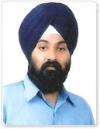  Mr. Tarandeep Singh
 | Designation | Asst. Prof.
 | Department | IT
 | Date of Joining the Institution | May 2012
 | Qualifications with Class/Grade | UG ;B.Com., PG: MCA PhD : Pursuing  -
 | Total Experience in Years | Teaching : 5 yrs Industry : 8 yrs  Research : -
 | Papers Published | National : - International : 3
 | Papers Presented in conferences | National : 1 International :
 | PhD Guide?Give field & University | Field:- Computer science University:- P.T.U
 | PhDs/Projects Guided | PhDs - Project at Masters Level:-
 | Books Published/IPRs/Patents | -
 | Professional Memberships | -
 | Consultancy Activities | -
 | Awards | -
 | Grants fetched | -
 | Interaction with Professional Institutions | -
14. | Admission Quota | Through Management /Counselling
 | Entrance Test/admission criteria | On merit
 | Cut off/last candidate admitted | 50 | 56 | 56
 | Fees in Rupees (Total for 3 Years) | 1,74,400/-(for 2 yrs) | 2,57,170/- | 2,57,170/-
 | Number of Fee Waivers offered | -- | -- | --
 | Admission Calender | (May16-Aug16) (May15-Aug15) (May14–Aug14)
 | PIO quota | No

 | 15. |  | Infrastructural information:
 |  |  | Classroom/Tutorial Room facilities |  | Photo
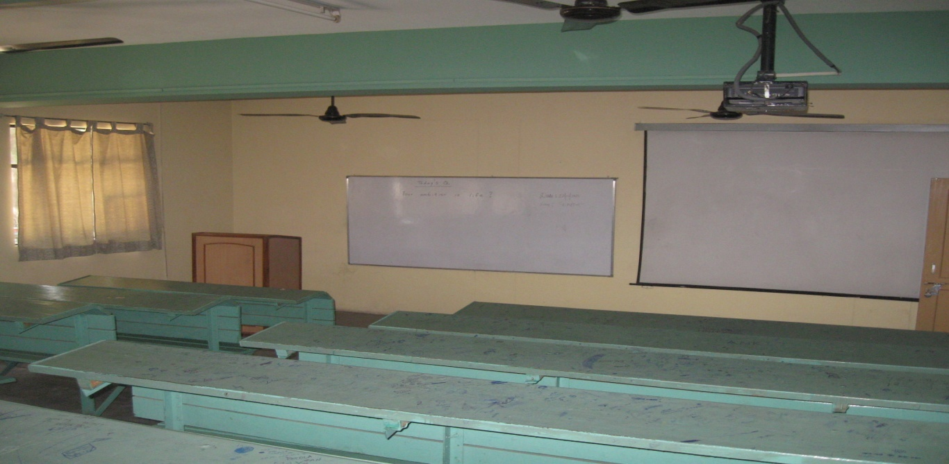
 |  | Laboratory details |  |  | Photo
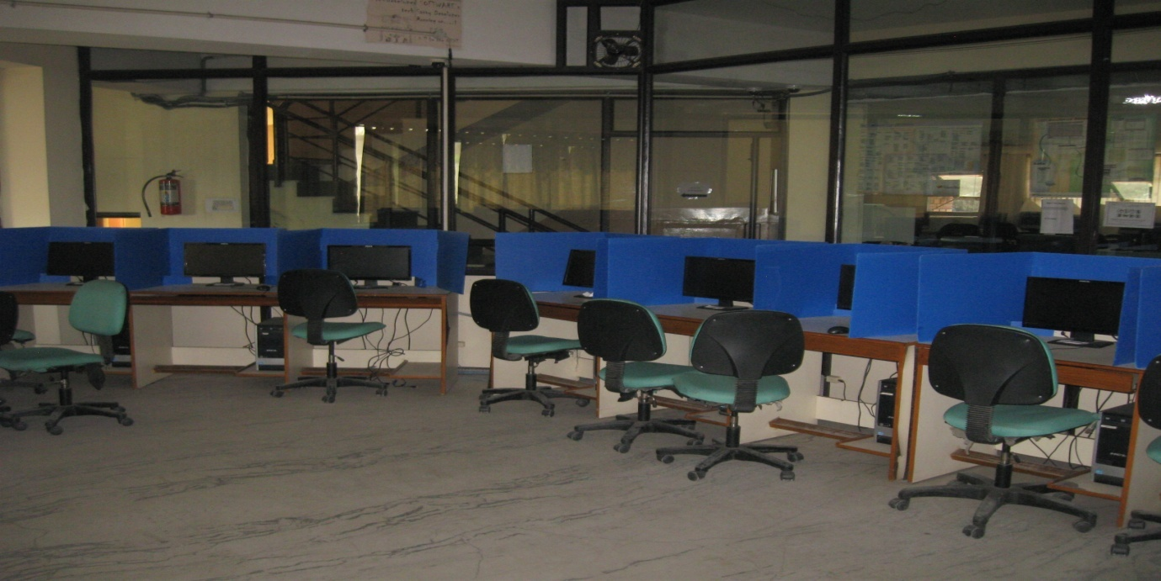

 |  | Computer Center facilities |  | Photo
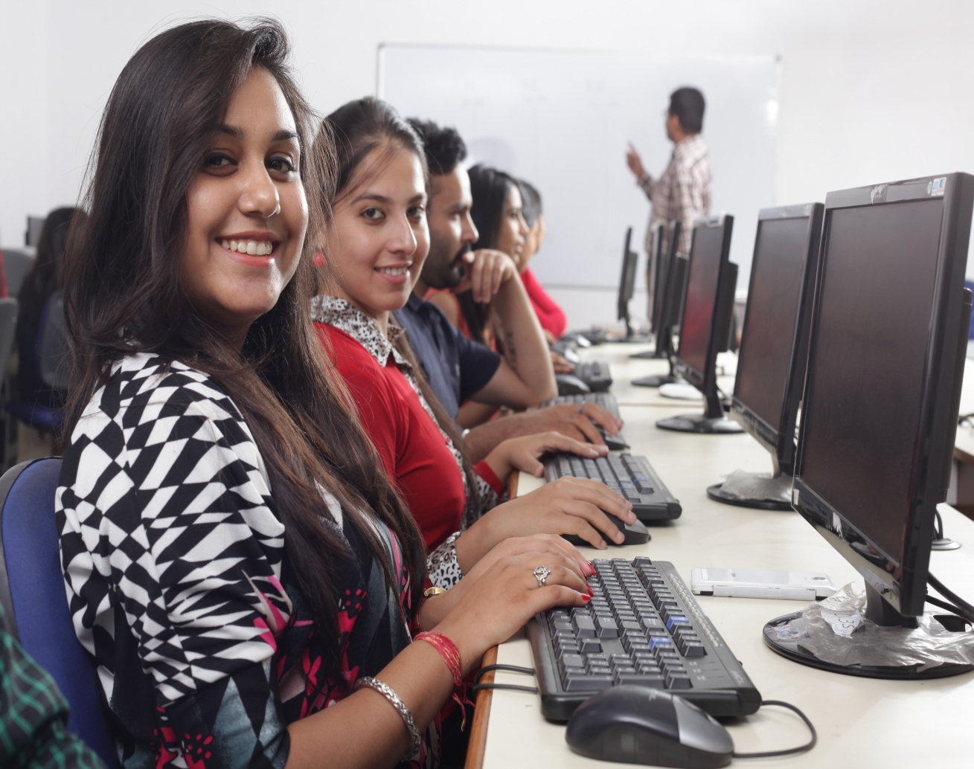
 |  | Library facilities |  | Photo

 | Auditorium/Seminar Halls/ Amphi | Photo
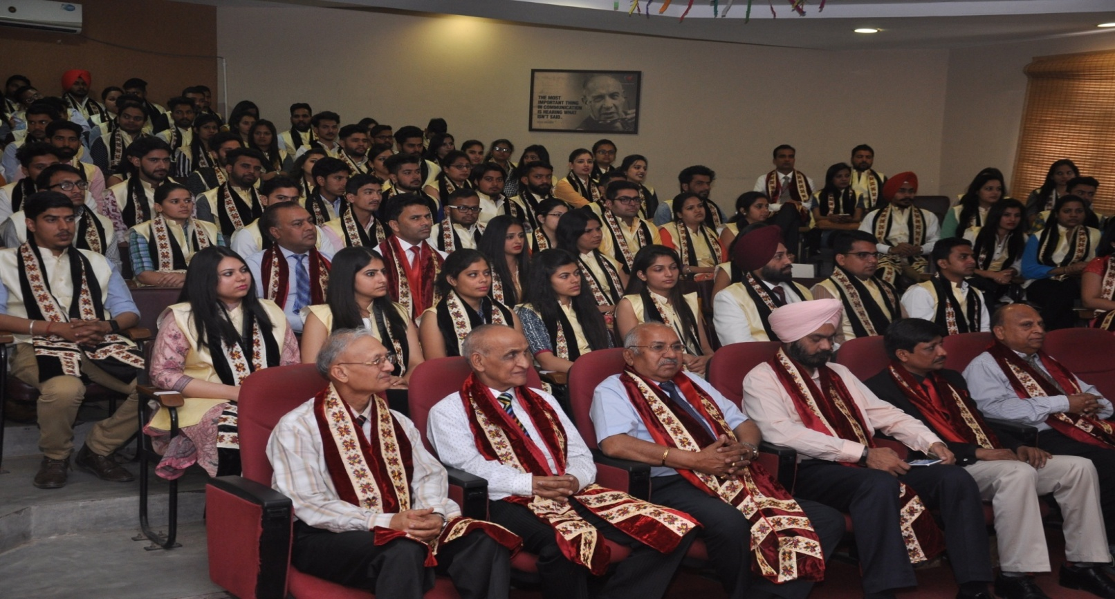

 | Cafeteria | Photo
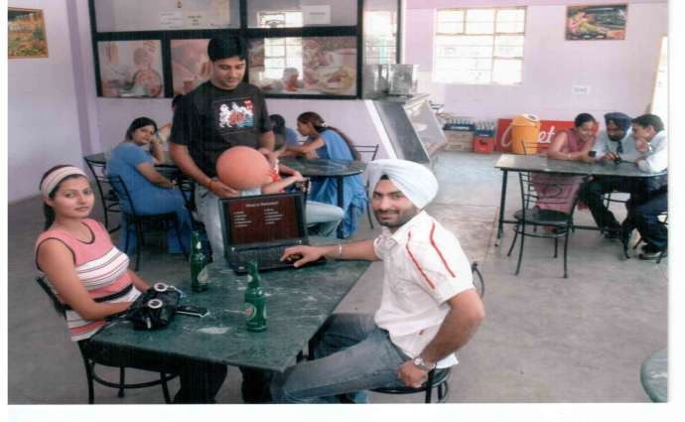
 | Indoor Sports facilities | Photo
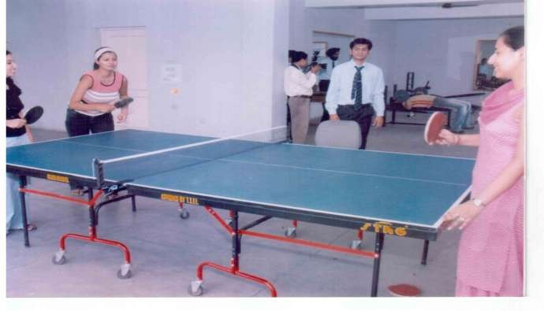

 | Outdoor Sports facilities | Photo
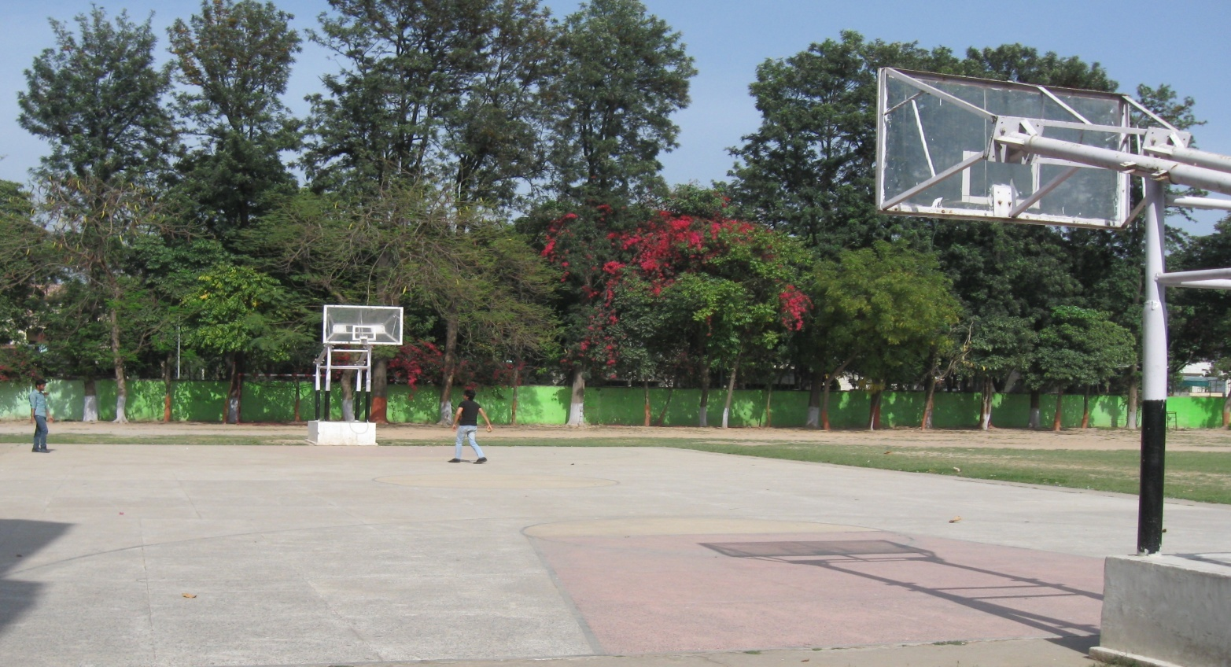
 | Gymnasium facilities | Photo
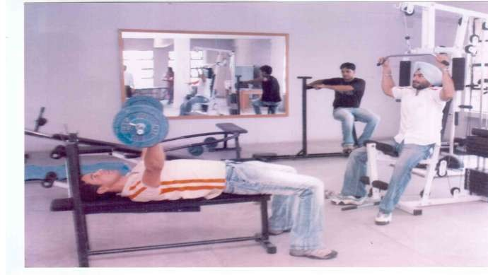

 | Facilities for disabled | Photo
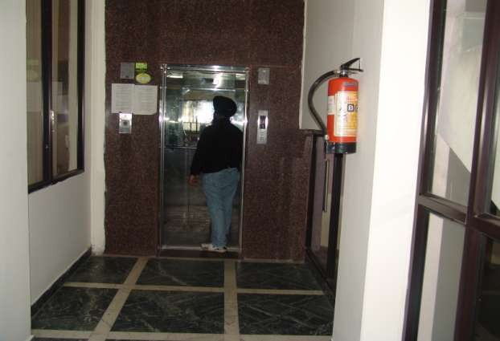

 | Any other facilities | Photo
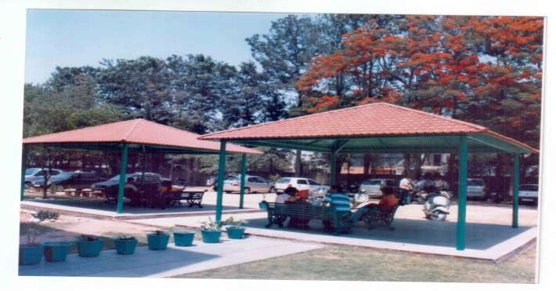

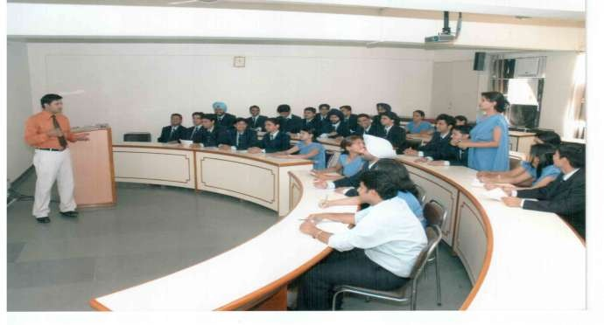
Any other facilities
Photo

 | 16. |  | Boys Hostel |  | Paying Guest Accommodation
 |  |  | Girls Hostel |  | Photo
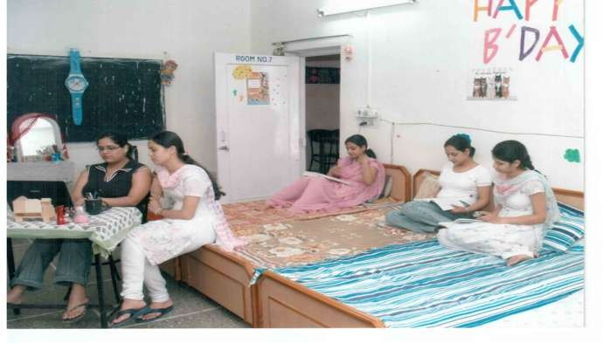

 |  | Medical & Other facilities at Hostel
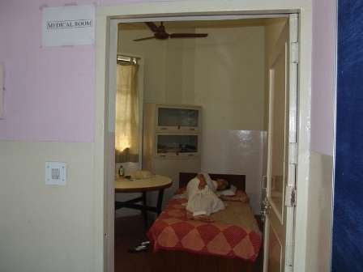
17. |  | Academic Sessions |  | 2016-17

 | Examination system,Year/Sem | Semester wise
 | Period of declaration of results | March-April, Sep-Oct

18. | Counselling/Mentoring | Yes
 | Career Counselling | Yes
 | Medical facilities | Yes
 | Student Insurance | No

19. | Students Activity Body | Hospitality, Marketing, HR & Finance Cell, Placement Cell, Scholastic Club, Cultural Club, Sports Club, Placement& Corporate Relations
 | Cultural activities | Kirtan Darbar; Social & Religious days celebrations Pratibha-An Intecollege Youth Fest, Parakh-Talent Hunt at GJ-IMT , World Theatre day, Daawate-E-Music, NSS Day Celebration, Young Munch (Videocon), Flag Day Celebration, Cooking Contest (cooking without fire), Multispecialty health check up camp
 | Sports activities | Cricket Competition, Athletics, Badminton Tournament,Table Tennis Tournament, Marathon
 | Literary activities | Quiz Competitions, Net PPt.Contests. Cross Talk, JAM Session, Product Plan Launch Contests etc., Young Mangers Contest, Turn Coat, Workshop on Leadership, Workshop on be socially intelligent, TiEcon
 | Magazines /Newsletter | Corporate Updates-Newsletter: Gyan Management-A Biannual International Refereed Journal
 | Technical activities/Tech Fest | IT Summit; e-collage competitions, On the Spot & Pre-Developed Software Competition
 | Industrial Visits/Tours | Reliance Industries(Hoshiarpur), RBI, Philips India, Mohali, Winsome Industries, Derabassi
 | Alumni activities | *Alumni Meets  *Guest Lectures by Alumni to Students  *Social welfare activities with Alumni  *Organization of competitions like Painting & Quiz at school level with alumni  * Networking Meet

20. | Name of the information Officer for RTI | Dr. Aneet
 | Designation | Director
 | Phone number with STD code | 0172-2264566
 | FAX number with STD code | 0172-2266979
 | Email | aneet@gjimt.ac.in

