 | Appendix 8
 | Mandatory Disclosure for MBA Programme
1. | AICTE File No. | North-West/1-2814225128/2017/EOA
 | Date & Period of last approval | 05.04.2016

2. | Name of Institution | Gian Jyoti Institute of Management & Technology
 | Address of Institution | Phase-2
 |  | Mohali.
 | City & Pin Code | Mohali -160 055
 | State/UT | Mohali, Punjab
 | Longitude & Latitude | 76.69, 30.78
 | Phone number with STD code | 0172-2264566
 | FAX number with STD code | 0172-2266979
 | Office hours at the Institution | 9.00 am to 5.00 pm
 | Academic hours at the Institution | 9.00 am to 4.00 pm
 | Email | gjimt@gjimt.com
 | Website | www.gjimt.ac.in
 | Nearest Railway Station (dist in KM) | At Mohali (8 km)
 | Nearest Airport(dist in KM) | At Mohali (13km)

3. | Type of Institution | Private –Self Financed
 | Category (1) of the Institution | Non Minority
 | Category (2) of the Institution | Co-Ed

4. | Name of the organization running  the Institution | Gian Jyoti Educational Society
 | Type of the organization | Society
 | Address of the organization | Gian Jyoti Educational Society
 |  | Phase-2 ,Mohali
 | Registered With | Registrar of Societies ,Punjab
 | Registration Date | 10.12.1976
 | Website of the organization | www.gjimt.ac.in

5. | Name of the affiliating University | I.K.G PTU
 | Address | Jalandhar-Kapurthla Road, Jalandhar
 | Website | www.ptu.ac.in
 | Latest affiliation period | 2016-17

6. | Name of Principal/Director | Dr. Aneet
 | Exact Designation | Director
 | Phone number with STD code | 0172-2264566
 | FAX number with STD code | 0172-2266979
 | Email | aneet@gjimt.ac.in
 | Highest Degree | Ph.D
 | Field of Specialization | HR

7. |  | Governing Board Members
 | Name |  | Academic Qualification |  | Nature of Association with the Promoting Body |  | Experience in Academic Institutions  (in Years) |  |  | Overall Experience  (in Years)
 |  |  | Technical | Non Technical |  |  | Promotional | Management | Organizational
 | Sh. A.D.Nagpal |  | - | B.A | Chairman |  | - | - | - | 48 yrs
 | Sh. Jaswant Singh Bedi |  | L.L.B. | B.A., | Secretary |  | - | 45 yrs | - | 45 yrs
 | Smt. Ranjeet Kaur Bedi |  | B.Ed | M.A., | Treasurer |  | - | - | 42 yrs | 42 yrs
 | Dr.S.P.S.Chawla |  | MBBS (MRSIA) | - | Member |  | - | - | - | 36 yrs
 | Sh. Harjit Singh |  | MBA |  | Member |  | - | - | - | 42 yrs
 | Dr. R.P. Gupta |  | Ph.D | M.Sc. | Member |  | - | - | 40 yrs | 40 yrs
 | Mr.Vivek Paul |  |  | MA | Member |  | - | - | - | 20 yrs
 | Mrs. Gian Jyot |  | B. Ed. | MA | Member |  | - | - | 14 yrs | 14 yrs
 | Dr. Aneet |  | PhD,MBA | B.Sc | Member |  | - | 17 yrs | - | 17 yrs
 |  | Frequency of meetings & date of last meeting |  |  |  | Twice a year

8. |  | Academic Advisory Body |  |  |  |  |  | List of Members given below
 |  |  |  | 1 |  | Sh. A.D.Nagpal |  |  |  | Chairman
 |  |  |  | 2 |  | Sh. J.S.Bedi |  |  |  | Secretary
 |  |  |  | 3 |  | Mrs. Ranjeet Bedi |  |  |  | Treasurer
 |  |  |  | 4 |  | Dr. Prem Kumar |  |  |  | Member
 |  |  |  | 5 |  | Sh. J.D, Ghai |  |  |  | Member
 |  |  |  |  | 6 |  | Sh. J. B. Singh |  |  |  | Member
 |  |  |  |  | 7 |  | Sh. Anupam Gakhar |  |  |  | Member
 |  |  |  |  | 8 |  | Sh. Swaranjit Singh |  |  |  | Member
 |  |  |  |  | 9 |  | Dr. S.P.S.Chawla |  |  |  | Member
 |  |  |  |  | 10 |  | Sh.Gurmeet Singh Bhatia |  |  |  | Member
 |  |  |  |  | 11 |  | Dr. Aneet |  |  |  | Member
 |  |  |  |  | 12 |  | Mrs. Gian Jyot |  |  |  | Member
 |  |  |  |  | 13 |  | Mr. Gurvinder Singh |  |  |  | Member
 |  |  |  |  | 14 |  | Mr. Rohit Aggarwal |  |  |  | Member
 |  |  |  |  | 15 |  | Sh. Vivek Paul |  |  |  | Member
 |  |  | Frequency of meeting & date of last meeting |  |  |  |  |  | Twice a Year

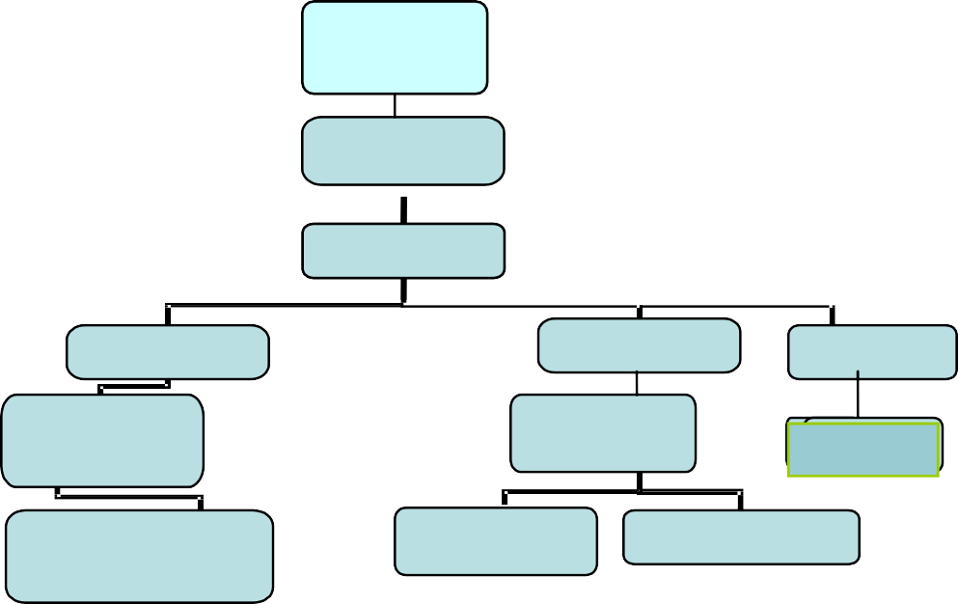
9.
Organizational Chart
Board of
Governors

Chairman
Director
Deans
CAO
Librarian
HOD
Office
suptd.
Astt.lib
Faculty
Security
Officer
Clerk

10. | Student feedback mechanism on Institutional Governance/faculty performance | Standardized format of faculty feedback is taken after semester end

11 | Grievance redressal mechanism for faculty, staff and students | Special Counselling sessions are held daily in the campus

 | 12. |  |  | Name of Department |  |  | Management
 |  |  |  | Course |  |  | MBA
 |  |  |  | Level |  |  | PG
 |  |  |  | Ist Year of approval by the Council |  |  | 2016 |  | 2015
 |  |  |  | Year wise sanctioned Intake |  |  | 180 |  | 180
 |  |  |  | Year wise Actual Admissions |  |  | 118 |  | 117
 |  |  |  | Cut off marks-General quota |  |  | 74.14 |  | 89.91
 |  |  |  | % Students passed with Distinction |  |  | 11 |  | 8
 |  |  |  | % Students passed with First Class |  |  | 82 |  | 75
 |  |  |  | Students Placed |  |  | 100 |  | 90
 |  |  |  | Average Pay Package, Rs/Year |  |  | 3.5 Lakhs |  | 3 Lakhs
 |  |  |  | Students opted for Higher Studies |  |  | - |  | -
 |  |  |  | Accreditation Status of the Course |  |  | Not Accredited
 |  |  |  | Doctoral Courses |  |  | Yes
 |  |  |  | Foreign Collaborations, if any |  |  | N.A
 |  |  |  | Professional Society Memberships |  |  | List given below.
 |  | S No |  |  | Organization |  |  | Type of Membership
 |  | 1 |  |  | The British Library |  |  | Institutional Member
 |  | 2 |  |  | National HRD Network Chandigarh |  |  | Permanent Institutional Membership
 |  | 3 |  |  | Chandigarh Management Association (CMA) |  |  | Life Membership
 |  | 4 |  |  | People Matters HR Magazines |  |  | Annual Subscription
 |  | 5 |  |  | IT Club Chandigarh |  |  | Life Membership
 |  | 6 |  |  | Punjab Commerce & Management Association (PCMA) |  |  | Life Member
 |  | 7 |  |  | The Indus Entrepreneurs (TiE) Chandigarh |  |  | Annual Tie Membership (Institutional )
 |  | 8 |  |  | Indian Society for Training & Development |  |  | Life Membership
 |  | 9 |  |  | Indian Society for Applied Behavioral Science ( ISABS) |  |  | Life Associate Membership
 |  | 10 |  |  | Chandigarh Club |  |  | Monthly Membership
 |  | 11 |  |  | Peta India |  |  | Annual Membership
 |  | 12 |  |  | Computer Society of India |  |  | Annual Institutional Membership
 |  | 13 |  |  | Indian Society for Technical Education |  |  | Institutional Membership fee
 |  | 14 |  |  | ASSOCHAM |  |  | Annual Member
 |  | 15 |  |  | FICCI |  |  | Annual Member
 |  | 16 |  |  | CII |  |  | Organizational Member
 |  | 17 |  |  | IEEE |  |  | Annual Member
 |  | 18 |  |  | DELNET |  |  | Annual Institutional Member
 |  | 19 |  |  | PHDCCI |  |  | Annual Member
 |  |  |  | Professional Activities |  |  | AICTE sponsored SDP-FDPs, International & National Conference, Summits – IT & HR, Pratibha
 |  |  |  | Consultancy Activities |  |  | TBRL, (ADRO Organisation) Training Programme with Groz Beckert Asia Ltd
 |  |  |  | Grants fetched |  |  | PTU Sponsored –  13th National Conference GJ-NatConMITE -2016  (Grant for Rs. 25,000/-)
 |  |  | Departmental Achievements |  |  | - Placements in reputed organization like HDFC Bank, Reckitt Benckiser, Axis Bank, SBI Life Insurance, Kotak Mahindra Bank, Gati, Airtel, DLF, Pepsi, Khaitan, WiproWep.  - .Organized various National and International conferences  - PTU Sponsored GianJyoti National Conference on Management, Information Technology, and Engineering, July 23, 2016  - GianJyoti International Conference on Management, Information Technology, and Engineering, March 18, 2017  3. PTU Sponsored Five-Days FDP onActivity and Project Based Teaching and Learning from 6thto 10thJuly, 2015  - HR Summit organized for active Industry-Institute Interface: 8th HR Summit on Leadership in Business, October 17, 2015
- Certifications:
S. No. | Course Name | Year Introduced | For students of which Semester/Term | Optional or Compulsory | Number of hours per semester/term | Batch Size
1 | Edx.org online certification | 2016 | MBA, MCA, BBA, BCA all semesters | Optional | 14 hrs. per semester | 112
2 | Certification in Digital Marketing | 2016 | MBA, MCA, BBA, BCA all semesters | Optional | 21 hrs. per semester | 112
3 | Certification in HR Essentials | 2016 | MBA Sem. 1 and Sem. 3 | Optional | 21 hrs. per semester | 57
4 | Certification in Supply Chain Management | 2016 | MBA Sem. 1 and Sem. 3 | Optional | 21 hrs. per semester | 25
5 | Certification in Capital Markets | 2016 | MBA Sem. 1 and Sem. 3 | Optional | 21 hrs. per semester | 25
6 | Certification in Business Analytics using Simulation | 2013 | MBA Sem. 1 and Sem. 3 | Optional | 21 hrs. per semester | 25-75
7 | Dining Etiquettes | 2016 | MBA, MCA, BBA, BCA all semesters | Optional | 1 day at Hotel Hyatt | 112
8 | Basic Golf | 2014 | MBA, MCA, BBA, BCA all semesters | Optional | 12 hrs. per semester | 60-112
9 | Functional English | 2013 | MBA, MCA, BBA, BCA all semesters | Optional | 14 hrs. per semester | 100-150

Alumni Details
Sr. | Name of Student | Present company Name/Address | Designation
1 | Prabhjot Singh | AXIS Bank | Branch Sales Manager
2 | Anand Sawhney | Ranbaxy Labs Ltd. | Manager- Materials(Purchase)
3 | Amrita Oberoi | HDB Financial Services | Management Trainee
4 | Gurpreet kaur | IFFCO Tokio General Insurance | ADM
5 | Harpreet Singh | Indiana Track Engineers | Executive Trainer
6 | Manish Mendiratta | Anand Pharma | MD
7 | Samrat Bhasin | Audi Cars | Sales Manager(Punjab)
8 | Amardeep Singh | Luminous inverter,gurgaon | HR manager
9 | Rajat Markanday | Bcms Clothing | Head( North)
10 | Salony Vadhera | India Infoline | Branch Manager
11 | Sarvaneer Singh | L & T Finance | Manager
12 | Ms Jaspreet Ahluwalia | Kotak mahindra | Deputy manager
13 | Rajan Mehandru | Just Dial | Executive Trainer
14 | Rakesh Parashar | AXIS Bank | Assitant manager
15 | Sumit Mahajan | ICICI Secutities | Management Trainer
16 | Padamdeep Singh | Anand Automotive systems | Head-HR
17 | Harleen Kaur | Decathlon | Sales Manager
18 | Damanjeet Singh | Paridyam Health Care | Business Development Officer
19 | Gurleen Kaur | Emrald Management Services | Branch Manager
20 | Varun Sachdeva | Just Dial | Executive Trainee

13 | Name of Teaching Staff | 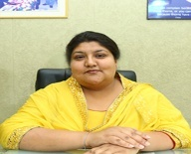  Dr. Aneet
 | Designation | Director
 | Department | Management
 | Date of Joining the Institution | 01.08.2001
 | Qualifications with Class/Grade | UG : BSc(Med) (3rd) PG: MBA (1st) PhD :HR
 | Total Experience in Years | Teaching : 12 yrs Industry : No  Research : 5 yrs
 | Papers Published | National : - 9 International -15
 | Papers Presented in conferences | National : - 3 International : 2
 | PhD Guide? Give field & University | Field : - HR University: -PTU
 | PhDs/Projects Guided | PhDs - 8 Project at Masters Level: 7
 | Books Published/IPRs/Patents | 7
 | Professional Memberships | 5
 | Consultancy Activities | 4
 | Awards | Rashtrapati Guide Award ,1996; ISABS Professional Development Programme-PhaseA
 | Grants fetched | -
 | Interaction with Professional Institutions | Yes ,Executive Council Member, TiE Chandigarh  President, Chandigarh Management Association (Affiliated to AIMA, New Delhi)

13 | Name of Teaching Staff | 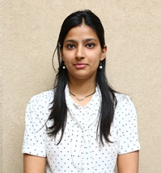  Dr. Sneha Sharma
 | Designation | Associate Professor
 | Department | Management
 | Date of Joining the Institution | 11th Jan 2016
 | Qualifications with Class/Grade | UG :B.sc PG:MBA PhD :Marketing
 | Total Experience in Years | Teaching : 2.5 yrs Industry : No  Research : 3.2 yrs
 | Papers Published | National : - 2 International -14
 | Papers Presented in conferences | National : - 2 International : 6
 | PhD Guide?Give field & University | Field : - NIL University: -NIL
 | PhDs/Projects Guided | PhDs - Project at Masters Level:
 | Books Published/IPRs/Patents
 | Professional Memberships
 | Consultancy Activities
 | Awards
 | Grants fetched
 | Interaction with Professional Institutions
13 | Name of Teaching Staff | 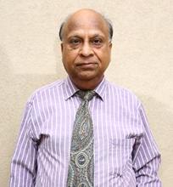  Mr. Ashok K. Mittal
 | Designation | Professor
 | Department | Management
 | Date of Joining the Institution | 19.10.2009
 | Qualifications with Class/Grade | UG : B.E (E&C) PG:MBA
 | Total Experience in Years | Teaching : 17 Industry : 25  Research
 | Papers Published | National : 7 International : 3
 | Papers Presented in conferences | National : 2 International : 1
 | PhD Guide? Give field & University | Field : - NIL University: - NIL
 | PhDs/Projects Guided | PhDs - Project at Masters Level:
 | Books Published/IPRs/Patents
 | Professional Memberships
 | Consultancy Activities
 | Awards
 | Grants fetched
 | Interaction with Professional Institutions
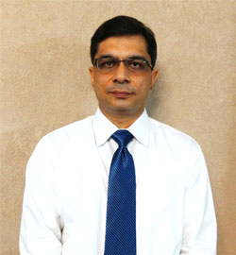
13 | Name of Teaching Staff | Mr. Rajneesh Mehra
 | Designation | Associate Professor
 | Department | Management
 | Date of Joining the Institution | 16.06.2012
 | Qualifications with Class/Grade | UG : B.sc PG:MBA
 | Total Experience in Years | Teaching : 15 Industry : 06  Research
 | Papers Published | National : 3 International : 1
 | Papers Presented in conferences | National : International :
 | PhD Guide? Give field & University | Field : - NIL University: - NIL
 | PhDs/Projects Guided | PhDs - Project at Masters Level:
 | Books Published/IPRs/Patents
 | Professional Memberships
 | Consultancy Activities
 | Awards
 | Grants fetched
 | Interaction with Professional Institutions

13 | Name of Teaching Staff | 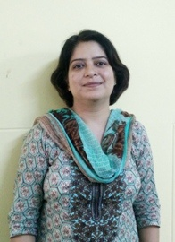  Ms. Rekha Sachdeva
 | Designation | Assistant Professor
 | Department | Management
 | Date of Joining the Institution | 23.08.2016
 | Qualifications with Class/Grade | UG : B.Com PG:M.com
 | Total Experience in Years | Teaching :14yrs Industry : Research :1
 | Papers Published | National : 6 International : 2
 | Papers Presented in conferences | National : 3 International : 2
 | PhD Guide? Give field & University | Field : - NIL University: - NIL
 | PhDs/Projects Guided | PhDs - Project at Masters Level:
 | Books Published/IPRs/Patents
 | Professional Memberships
 | Consultancy Activities
 | Awards
 | Grants fetched
 | Interaction with Professional Institutions

13 | Name of Teaching Staff | 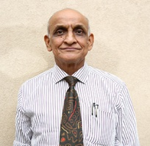  Dr. A. N Garg
 | Designation | Professor
 | Department | Management
 | Date of Joining the Institution | 09.01.2012
 | Qualifications with Class/Grade | UG : B.Com PG:M.com  PhD:- Financial Management and Accounting
 | Total Experience in Years | Teaching : 45yrs Industry : Research :3
 | Papers Published | National : International :
 | Papers Presented in conferences | National : 2 International :
 | PhD Guide? Give field & University | Field : - NIL University: - NIL
 | PhDs/Projects Guided | PhDs Level -180 Project at Masters
 | Books Published/IPRs/Patents
 | Professional Memberships
 | Consultancy Activities
 | Awards | Felicitation by Bank of India for 1st position in Univ.
 | Grants fetched
 | Interaction with Professional Institutions

13 | Name of Teaching Staff | 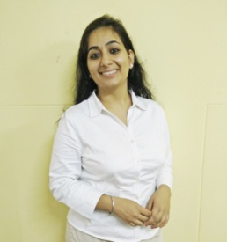  Ms. Harleen Kaur
 | Designation | Assistant Professor
 | Department | Management
 | Date of Joining the Institution | 13.07.2016
 | Qualifications with Class/Grade | UG : B.Com(Hons.) C.A
 | Total Experience in Years | Teaching : 1 Industry : 6 Research :
 | Papers Published | National : International :
 | Papers Presented in conferences | National : International :
 | PhD Guide? Give field & University | Field : - NIL University: - NIL
 | PhDs/Projects Guided | PhD level- 10 Project at Masters
 | Books Published/IPRs/Patents
 | Professional Memberships | Yes, Chartered Accountant
 | Consultancy Activities
 | Awards
 | Grants fetched
 | Interaction with Professional Institutions

13 | Name of Teaching Staff | 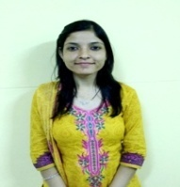  Ms. Richa Saini
 | Designation | Assistant Professor
 | Department | Management
 | Date of Joining the Institution | 25.07.2016
 | Qualifications with Class/Grade | UG : B.Sc P.G : MBA
 | Total Experience in Years | Teaching:6 yrs Industry:1 yr Research :
 | Papers Published | National : 2 International : 2
 | Papers Presented in conferences | National : International :
 | PhD Guide? Give field & University | Field : NIL University: NIL
 | PhDs/Projects Guided | PhD level- Project at Masters
 | Books Published/IPRs/Patents
 | Professional Memberships
 | Consultancy Activities
 | Awards
 | Grants fetched
 | Interaction with Professional Institutions

13 | Name of Teaching Staff | 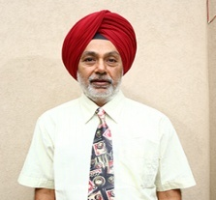  Mr. Gurdeepak Singh
 | Designation | Professor
 | Department | Management
 | Date of Joining the Institution | 10-03-2010
 | Qualifications with Class/Grade | UG: B.E (1st ) PG: B.A(1st ), M.Tech(1st )  PHD:
 | Total Experience in Years | Teaching: 17yrs Industry: 14 yrs  Research:
 | Papers Published | National: 2 International: 2
 | Papers Presented in conferences | National: International:
 | PhD Guide? Give field & University | Field : University:-
 | PhDs/Projects Guided | PhDs : Project at Masters Level:- 25
 | Books Published/IPRs/Patents
 | Professional Memberships | CII
 | Consultancy Activities | - Language Proficiency company from UK  - International Tie-Ups  - CRU for Nt Community College
 | Awards | -
 | Grants fetched
 | Interaction with Professional Institutions | International Universities and colleges from US, CANADA, UK, NEWZEALAND & AUSTRALIA

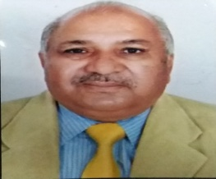
13 | Name of Teaching Staff | Dr. T. L. Kaushal
 | Designation | Professor
 | Department | Management
 | Date of Joining the Institution | 18-01-2017
 | Qualifications with Class/Grade | UG :BA  PhD : - | PG:MA, M.Com MBA LLB PhD.
 | Total Experience in Years | Teaching | :- 37yrs Industry : Research : -7 yrs
 | Papers Published | National | : -2 International
 | Papers Presented in conferences | National | - International : -1
 | PhD Guide? Give field & University | Field : | - University:-
 | PhDs/Projects Guided | PhDs - | Project at Masters Level:-
 | Books Published/IPRs/Patents | - 7
 | Professional Memberships | - Pb. & Hr high court Bar Association,CMA,AIMA
 | Consultancy Activities | -
 | Awards | -
 | Grants fetched | -
 | Interaction with Professional Institutions | -

13 | Name of Teaching Staff | PARNEET KAUR SODHI |  | 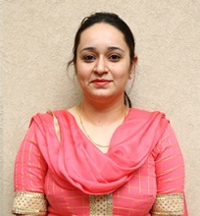
 | Designation | Assistant Professor
 | Department | Management
 | Date of Joining the Institution | 15-02-2016
 | Qualifications with Class/Grade | UG :B.SC(N.M)  PhD : -Pursuing | PG:M.Sc Maths
 | Total Experience in Years | Teaching | :- 4.5yrs Industry : yrs Research : -7
 | Papers Published | National | : International
 | Papers Presented in conferences | National | -1 International : -1
 | PhD Guide? Give field & University | Field :Education | - University:-PBI University Patiala
 | PhDs/Projects Guided | PhDs - | Project at Masters Level:-
 | Books Published/IPRs/Patents | -
 | Professional Memberships | -
 | Consultancy Activities | -
 | Awards | -
 | Grants fetched | -
 | Interaction with Professional Institutions | -

13 | Name of Teaching Staff | ISHA VERMA |  | 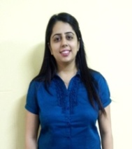
 | Designation | Assistant Professor
 | Department | Management
 | Date of Joining the Institution | 15-02-2016
 | Qualifications with Class/Grade | UG : B.Com  PhD : -Pursuing | PG:MBA
 | Total Experience in Years | Teaching | : 4 yrs Industry : Research : -7
 | Papers Published | National | : 2 International
 | Papers Presented in conferences | National | :1 International :
 | PhD Guide? Give field & University | Field : | - University:-
 | PhDs/Projects Guided | PhDs - | Project at Masters Level:-
 | Books Published/IPRs/Patents | -
 | Professional Memberships | -
 | Consultancy Activities | -
 | Awards | -
 | Grants fetched | -
 | Interaction with Professional Institutions | -

14. | Admission Quota | Through Management /Counselling
 | Entrance Test/admission criteria | On merit
 | Cut off/last candidate admitted | 50 | 57 | 58
 | Fees in Rupees (Total for 2 Yrs.) | Rs.177400/- | Rs.180980/- | Rs.180980/-
 | Number of Fee Waivers offered | 0 | 0 | 0
 | Admission Calendar | (May16-Aug16) (May15-Aug15) (May14- Aug14)
 | PIO quota | No

15. | Infrastructural information:
 | Classroom/Tutorial Room facilities | Photo
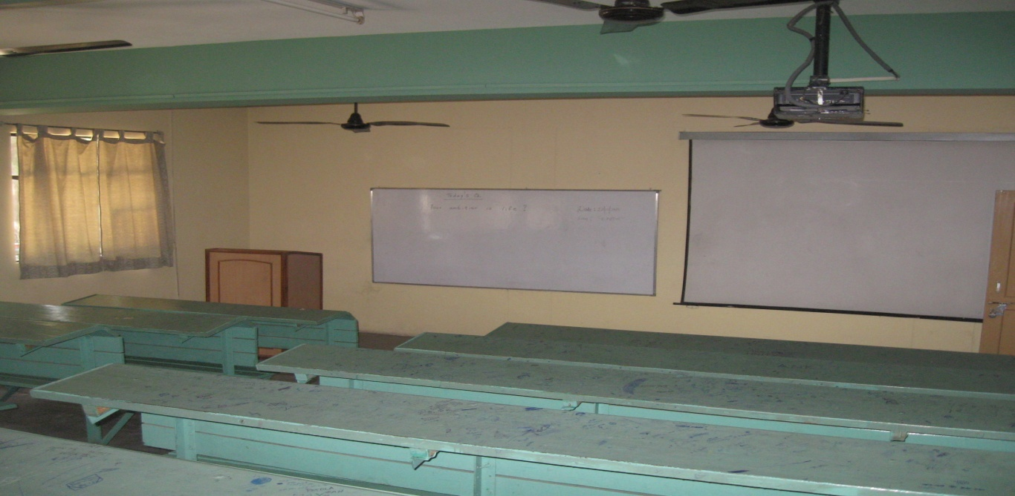
 | Laboratory details | Photo
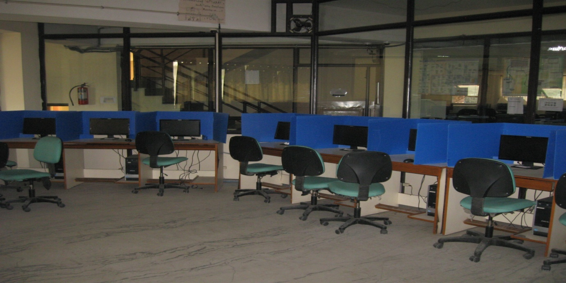

 | Computer Center facilities | Photo
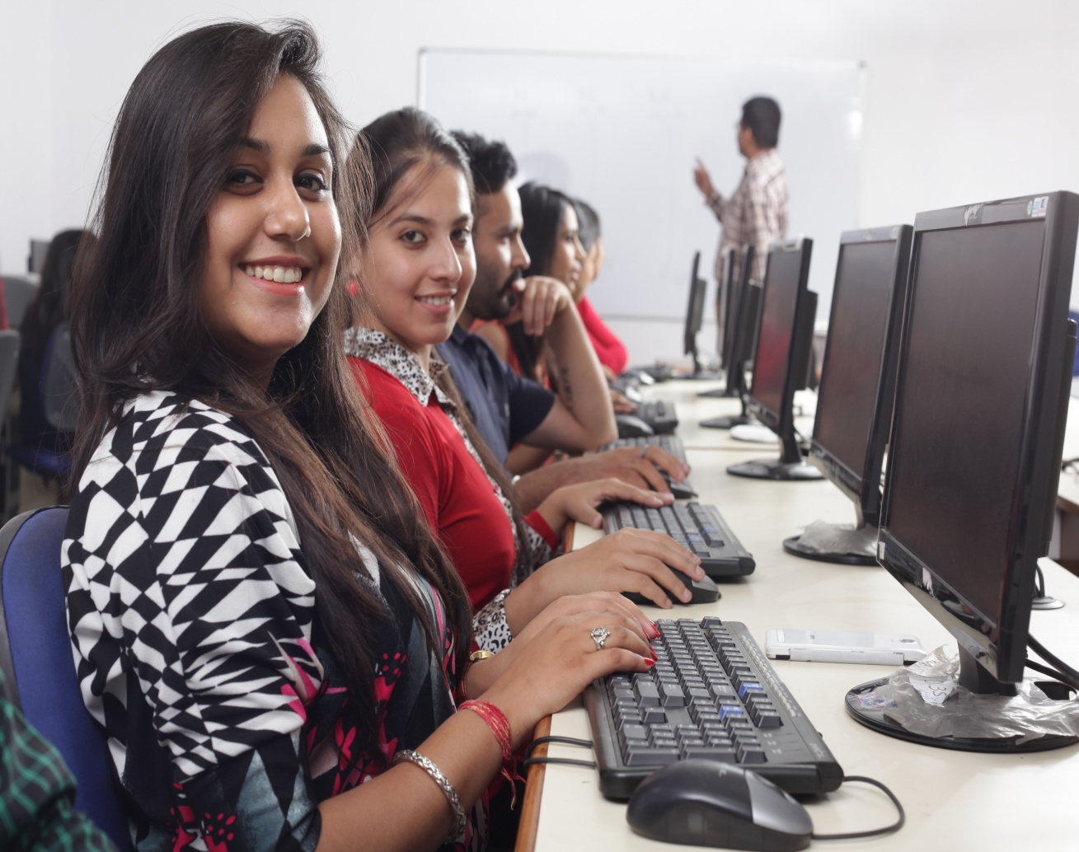
 | Library facilities | Photo

 | Auditorium/Seminar Halls/ Amphi | Photo
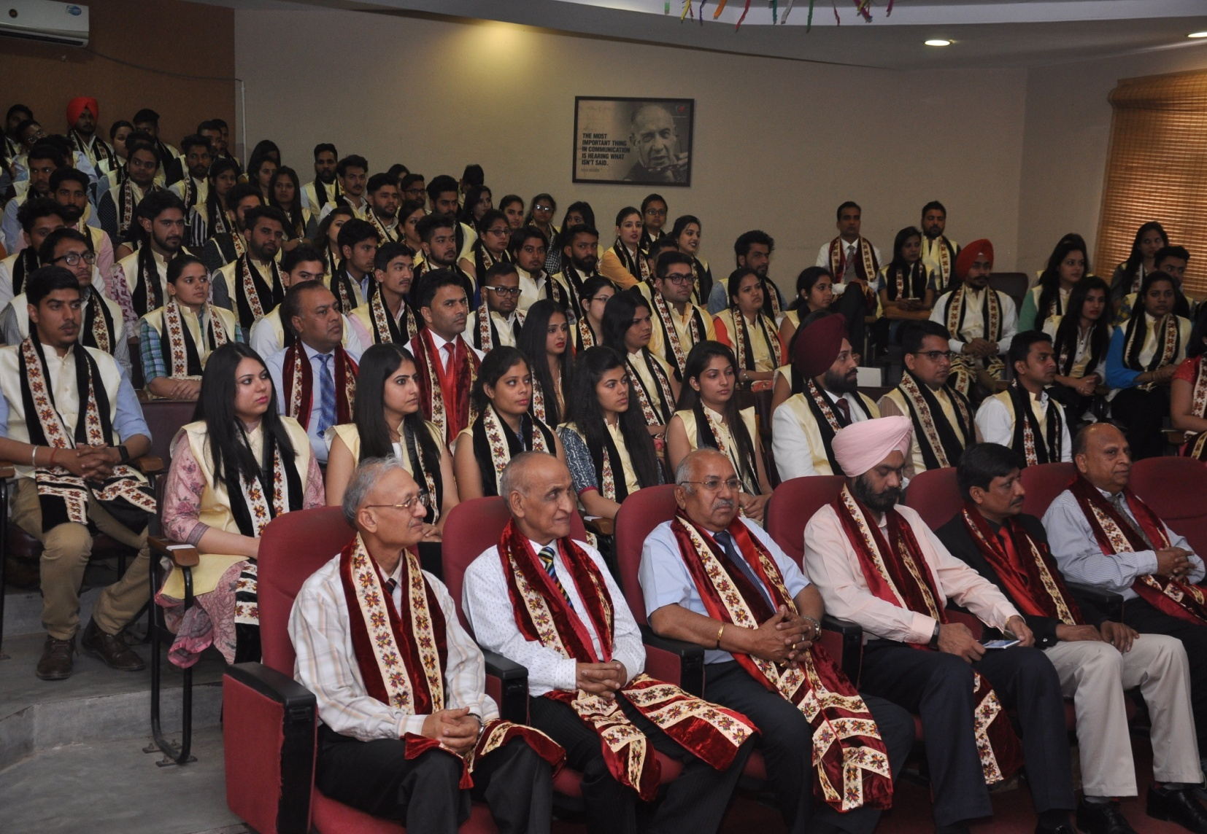

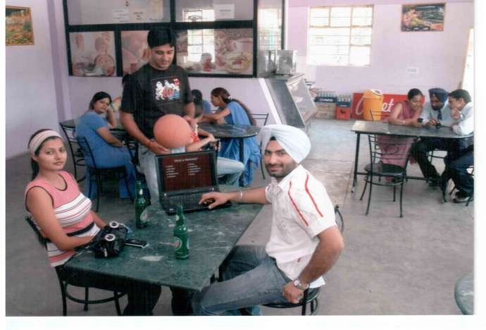
Cafeteria Photo

 | Indoor Sports facilities | Photo
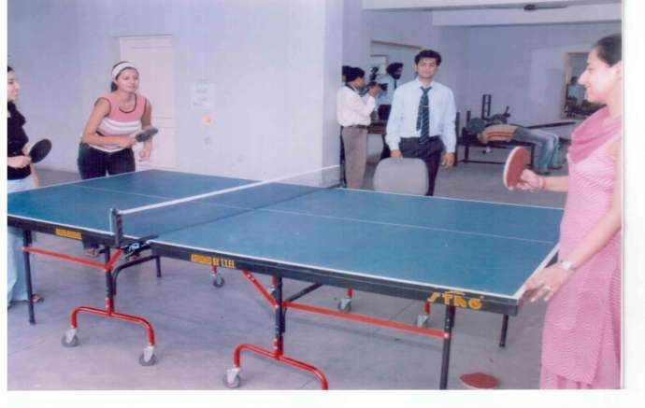
 | Outdoor Sports facilities | Photo
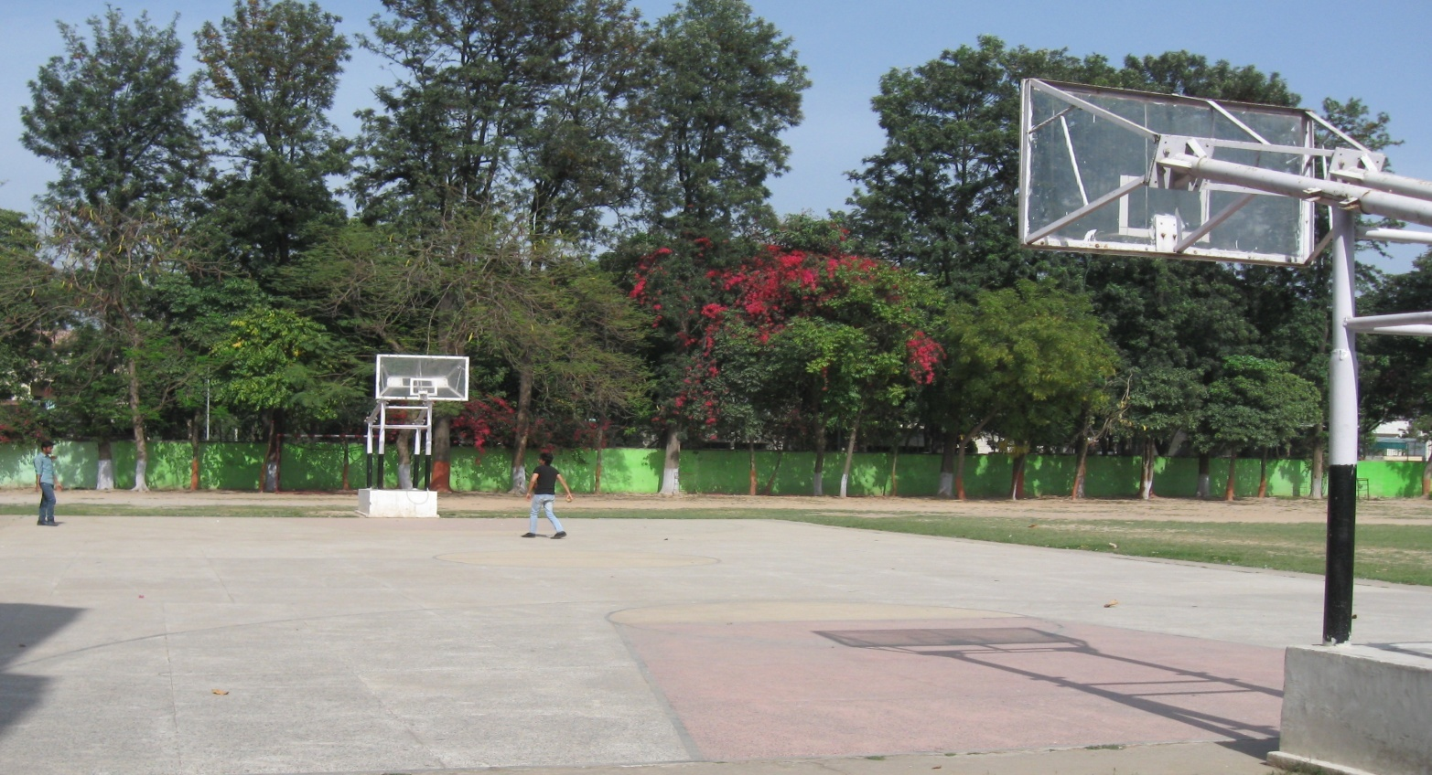

 | Gymnasium facilities | Photo
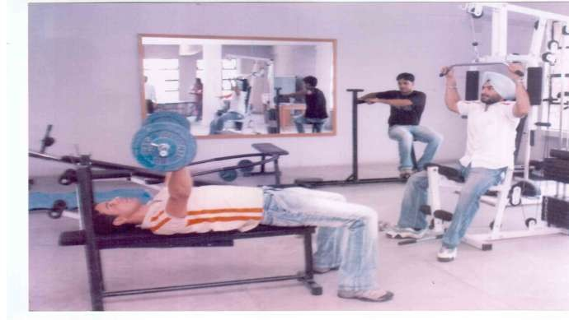
 | Facilities for disabled | Photo
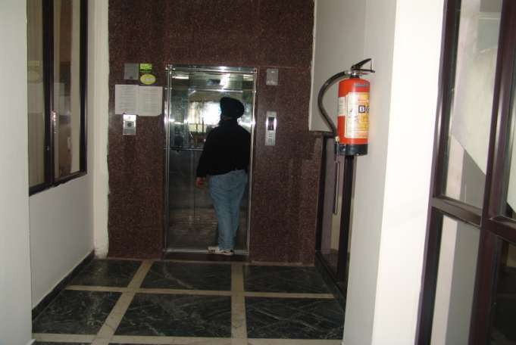

 | Any other facilities | Photo
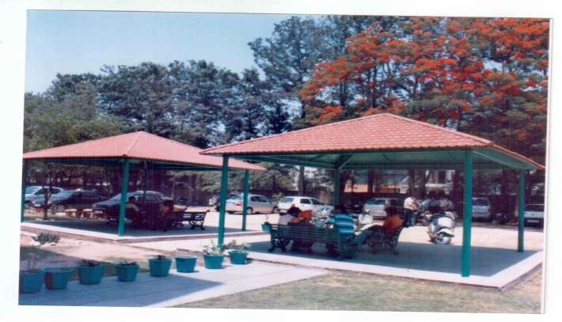
 | Any other facilities | Photo
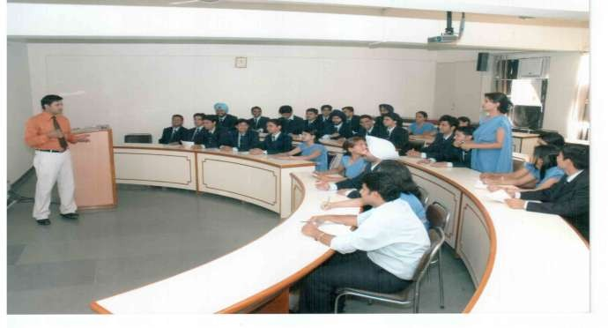

16. | Boys Hostel | Paying Guest Accommodation
 | Girls Hostel | Photo
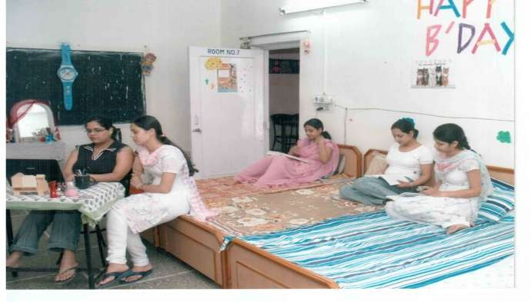
 | Medical & Other facilities at Hostel | Photo
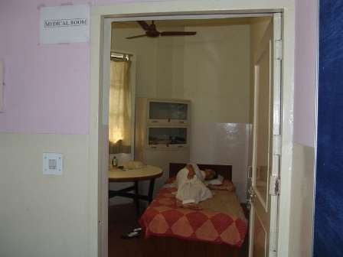

17. |  | Academic Sessions |  | 2016-17
 |  | Examination system (Year/Sem) |  | Semester wise
 |  | Period of declaration of results |  | March-April, Sep-Oct
18. |  | Counselling/Mentoring |  |  | Yes
 |  | Career Counselling |  |  | Yes
 |  | Medical facilities |  |  | Yes
 |  | Student Insurance |  |  | No
 | 19. |  | Students Activity Body |  |  | Hospitality, Marketing, HR & Finance Cell, Placement Cell, Scholastic Club, Cultural Club, Sports Club, Placement& Corporate Relations
 |  |  | Cultural activities |  |  | Kirtan Darbar; Social & Religious days celebrations Pratibha-An Intecollege Youth Fest, Parakh-Talent Hunt at GJ-IMT , World Theatre day, Daawate-E-Music, NSS Day Celebration, Young Munch (Videocon), Flag Day Celebration, Cooking Contest (cooking without fire), Multispecialty health check up camp
 |  |  | Sports activities |  |  | Cricket Competition, Athletics, Badminton Tournament,Table Tennis Tournament, Marathon
 |  |  | Literary activities |  |  | Quiz Competitions, Net PPt.Contests. Cross Talk, JAM Session, Product Plan Launch Contests etc., Young Mangers Contest, Turn Coat, Workshop on Leadership, Workshop on be socially intelligent, TiEcon
 |  |  | Magazines /Newsletter |  |  | Corporate Updates-Newsletter: Gyan Management-A Biannual International Refereed Journal
 |  |  | Technical activities/Tech Fest |  |  | IT Summit; e-collage competitions, On the Spot & Pre-Developed Software Competition
 |  |  | Industrial Visits/Tours |  |  | Reliance Industries(Hoshiarpur), RBI, Philips India, Mohali, Winsome Industries, Derabassi
 |  |  | Alumni activities |  |  | *Alumni Meets  *Guest Lectures by Alumni to Students  *Social welfare activities with Alumni  *Organization of competitions like Painting & Quiz at school level with alumni  * Networking Meet

20. | Name of the information Officer for RTI | Dr. Aneet
 | Designation | Director
 | Phone number with STD code | 0172-2264566
 | FAX number with STD code | 0172-2266979
 | Email | aneet@gjimt.ac.in

